|  |
| --- |
| Mohammad Hanif Furqan Aufa Putra |
| 5025221161 |
| Pembelajaran Mesin |
| H |

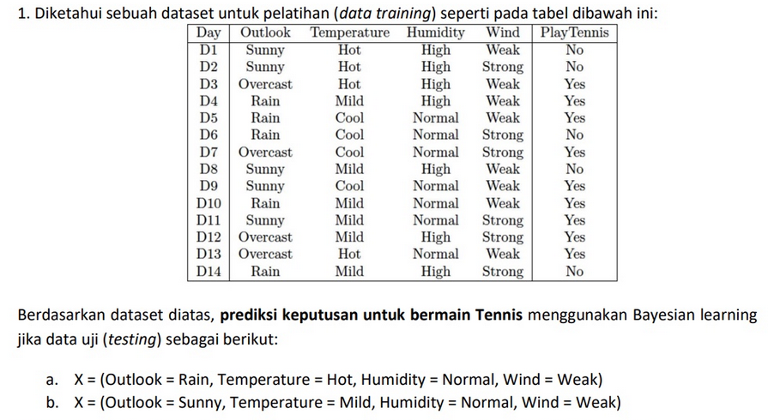

* P(Outlook = Sunny | No) = 3/5
* P(Outlook = Sunny | Yes) = 2/9
* P(Outlook = Overcast | No) = 0
* P(Outlook = Overcast | Yes) = 4/9
* P(Outlook = Rain | No) = 2/5
* P(Outlook = Rain | Yes) = 3/9 = 1/3
* P(Temperature = Hot | No) = 2/5
* P(Temperature = Hot | Yes) = 2/9
* P(Temperature = Mild | No) = 2/5
* P(Temperature = Mild | Yes) = 4/9
* P(Temperature = Cool | No) = 1/5
* P(Temperature = Cool | Yes) = 3/9 = 1/3
* P(Humidity = High | No) = 4/5
* P(Humidity = High | Yes) = 3/9 = 1/3
* P(Humidity = Normal | No) = 1/5
* P(Humidity = Normal | Yes) = 6/9 = 2/3
* P(Wind = Weak | No) = 2/5
* P(Wind = Weak | Yes) = 6/9 = 2/3
* P(Wind = Strong | No) = 3/5
* P(Wind = Strong | Yes) = 3/9 = 1/3

a. X = (Outlook = Rain, Temperature = Hot, Humidity = Normal, WInd = Weak)

Class No:

* P(Outlook = Rain | No) = 2/5
* P(Temperature = Hot | No) = 2/5
* P(Humidity = Normal | No) = 1/5
* P(Wind = Weak | No) = 2/5
* P(X | No) = 2/5 * 2/5 * 1/5 * 2/5 = 8/625 = 0.0128

Class Yes:

* P(Outlook = Rain | Yes) = 3/9 = 1/3
* P(Temperature = Hot | Yes) = 2/9
* P(Humidity = Normal | Yes) = 6/9 = 2/3
* P(Wind = Weak | Yes) = 6/9 = 2/3
* P(X | Yes) = 1/3 * 2/9 * 2/3 * 2/3 = 8/243 = 0.0329

Karena P(X | Yes) > P(X | No), maka Class = Yes, bermain tennis

b. X = (Outlook = Sunny, Temperature = Mild, Humidity = Normal, WInd = Weak) Class No:

* P(Outlook = Sunny | No) = 3/5
* P(Temperature = Mild | No) = 2/5
* P(Humidity = Normal | No) = 1/5
* P(Wind = Weak | No) = 2/5
* P(X | No) = 3/5 * 2/5 * 1/5 * 2/5 = 12/625 = 0.0192

Class Yes:

* P(Outlook = Sunny | Yes) = 2/9
* P(Temperature = Mild | Yes) = 4/9
* P(Humidity = Normal | Yes) = 6/9 = 2/3
* P(Wind = Weak | Yes) = 6/9 = 2/3
* P(X | Yes) = 2/9 * 4/9 * 2/3 * 2/3 = 32/729 = 0.0439

Karena P(X | Yes) > P(X | No), maka Class = Yes, bermain tennis

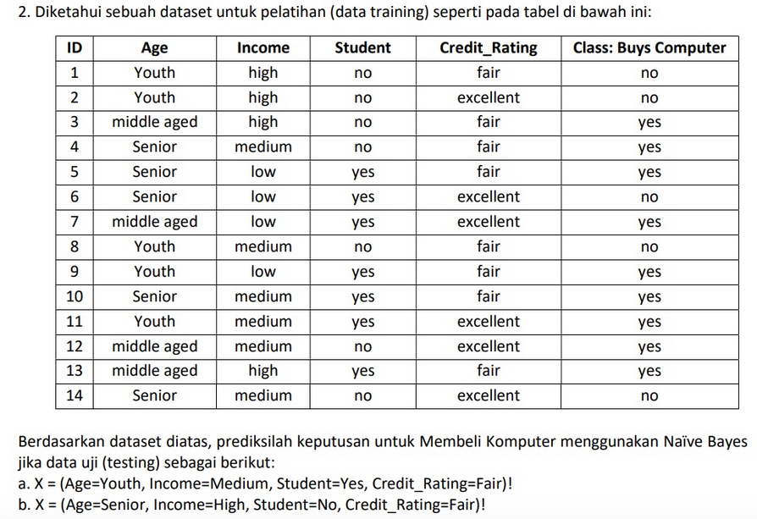

* P(Age = Youth | No) = 3/5
* P(Age = Youth | Yes) = 2/9
* P(Age = Middle aged | No) = 0/5 = 0
* P(Age = Middle aged | Yes) = 4/9
* P(Age = Senior | No) = 2/5
* P(Age = Senior | Yes) = 3/9 = 1/3
* P(Income = High | No) = 2/5
* P(Income = High | Yes) = 2/9
* P(Income = Medium | No) = 2/5
* P(Income = Medium | Yes) = 4/9
* P(Income = Low | No) = 1/5
* P(Income = Low | Yes) = 3/9 = 1/3
* P(Student = No | No) = 4/5
* P(Student = No | Yes) = 3/9 = 1/3
* P(Student = Yes | No) = 1/5
* P(Student = Yes | Yes) = 6/9 = 2/3
* P(Credit_Rating = Fair | No) = 2/5
* P(Credit_Rating = Fair | Yes) = 6/9 = 2/3
* P(Credit_Rating = Excellent | No) = 3/5
* P(Credit_Rating = Excellent | Yes) = 3/9 = 1/3

a. X = (Age=Youth, Income=Medium, Student=Yes, Credit_Rating=Fair)

Class No:

* P(Age = Youth | No) = 3/5
* P(Income = Medium | No) = 2/5
* P(Student = Yes | No) = 1/5
* P(Credit_Rating = Fair | No) = 2/5
* P(X | No) = 3/5 * 2/5 * 1/5 * 2/5 =12/625 = 0.0192

Class Yes:

* P(Age = Youth | Yes) = 2/9
* P(Income = Medium | Yes) = 4/9
* P(Student = Yes | Yes) = 6/9 = 2/3
* P(Credit_Rating = Fair | Yes) = 6/9 = 2/3
* P(X | Yes) = 2/9 * 4/9 * 2/3 * 2/3 = 32/729 = 0.0439

Karena P(X | Yes) > P(X | No), maka Class = Yes, membeli

b. X = (Age=Senior, Income=High, Student=No, Credit_Rating=Fair)

Class No:

* P(Age = Senior | No) = 2/5
* P(Income = High | No) = 2/5
* P(Student = No | No) = 4/5
* P(Credit_Rating = Fair | No) = 2/5
* P(X | No) = 2/5 * 2/5 * 4/5 * 2/5 = 32/625 = 0.0512

Class Yes:

* P(Age = Senior | Yes) = 3/9 = 1/3
* P(Income = High | Yes) = 2/9
* P(Student = No | Yes) = 3/9 = 1/3
* P(Credit_Rating = Fair | Yes) = 6/9 = 2/3
* P(X | Yes) = 1/3 * 2/9 * 1/3 * 2/3 = 4/243 = 0.0165

Karena P(X | No) > P(X | Yes), maka Class = No, tidak membeli komputer